Assignment 1  
CS3550  
Nathan Brooks  
  
1:

1. Does the database allow payments to not be associated with a customer? Can a single payment pay for two customers’ invoices?
   1. No, a payment can have one and only one customer.
   2. No, a payment can have one and only one customer.
2. Can a fortune teller have multiple mentors? Can they have no mentors at all? Can a fortune teller be listed as his / her own mentor?
   1. Yes, a fortune teller can have multiple mentors
   2. They can have no mentors
   3. A fortune teller can be his/her own mentor
3. Can a session have no predictions associated with it?
   1. Yes, predictions are optional, there can be none to many predictions
4. Can a session involve two customers? What about two fortune tellers?
   1. No, a session can have 1 and only 1 customer
   2. No, a session can have 1 and only 1 fortune teller
5. Can a customer have two addresses on file? Can they have no address?
   1. No, a customer can have 0 to 1 addresses
   2. Yes, a customer can have 0 addresses
6. Looking at a particular prediction, is it possible to know who made it, what client it was for, and what method of fortune-telling was used for it? Explain.
   1. You can tell what session a prediction occurred in, what fortune teller made the prediction, and what customer was in that session, but there are no keys defined in this diagram so you cannot tell exactly what method was used.
7. Is it possible to identify to which session a particular payment applies? Explain.
   1. No, you can tell what customer a session has, as a session can have 1 and only 1 customer, but a customer can have many payments, they are not associated with particular sessions.
8. Invoices are issued at the end of each month. When preparing an invoice for a particular customer, how would the system determine the amount to bill? Would it be possible to send customer an invoice specifying to what session each item corresponds?
   1. The invoice contains billable items which have amounts, and customers have invoices. You would grab the invoices associated with a customer, then add up all the amounts of the billable items associated with given invoices.
   2. Billable items can be associated with a session, and a customer can be associated with a session. Billable items can be associated with invoices, and invoices can be associated with customers. Through some logic one could deduce that the sets of billable items are the same, but you could not directly tell which billable items on an invoice went with what session.
9. Madame Z pays her fortune tellers based on how much money each of them brought in. Will she be able to figure out how much of her revenue comes from a particular fortune teller? Suppose that Madame Z wants to only pay fortune tellers when the customers whom they served actually pay their bills. Will she be able to do that?
   1. Yes, you can tell what sessions are associated with which fortune tellers, and you can tell which billable items are associated with each session. Since billable items have an amount, you could add up all the billable items for that fortune teller.
   2. Yes, a fortune teller can have customers, and they have payments. You can tell that a payment for a specific fortune teller was made.
10. Does the diagram contain any relations that would need to be broken-up with associative entities? If so, which ones? Explain.
    1. Any many-to-many relationship will need to be broken up through an associative entity. The relations that need to be broken up are:
       1. Fortune teller to fortune teller
       2. Fortune teller to method

2:

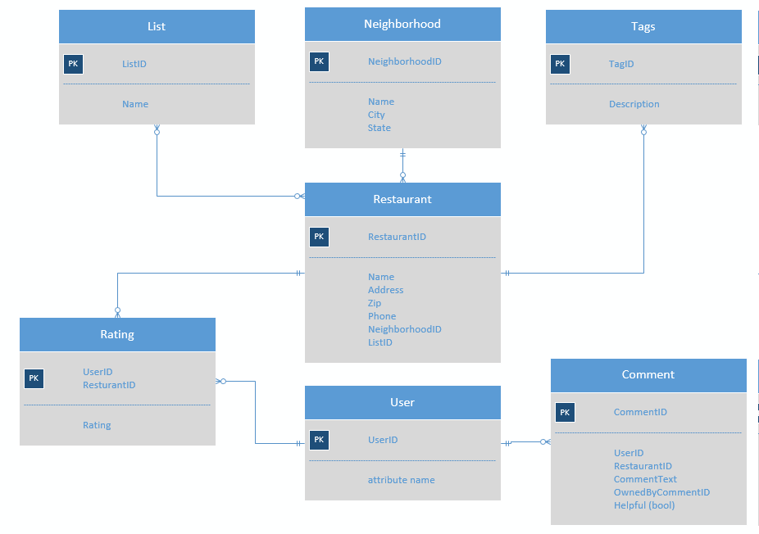

3:

